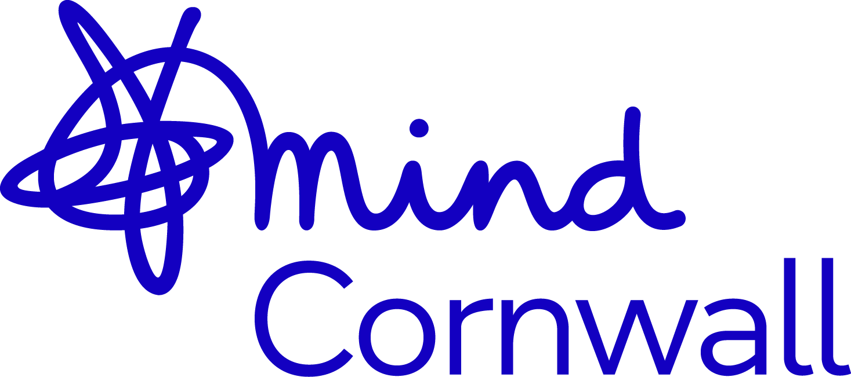

Job Description and Person Specification
for the position of:

Recovery Supporter

Date: 2025

Hours of Work: Various

Base: Bodmin

Salary: £12.60 per hour

Fixed term

Cornwall Mind is committed to working towards a fairer world and does not discriminate against any employee or job applicant on the grounds of age, disability, gender reassignment, marriage and civil partnership, pregnancy and maternity, race, religion or belief, sex or sexual orientation.

About Mind

Society’s attitude to mental health is being transformed, and Mind is at the forefront of that change.

Together, we’re keeping mental health at the heart of political agendas, improving public attitudes and supporting millions of people experiencing a mental health problem. Last year alone, we reached over 390,000 people through our local Mind services, whilst Time to Change – our campaign in partnership with Rethink Mental Illness - has seen a 12.7% improvement in attitudes towards people experiencing mental health problems since 2008.

But we won’t stop until everyone experiencing a mental health problem gets both support and respect. We are leading the way in wellbeing at work, reaching over 1 million employees in the last three years, and we will continue to play a central role in holding government to account in England and Wales, demanding the successful delivery of national mental health strategies so that everybody, in every community, feels the benefits.

Together, we’ll keep challenging attitudes, influencing government and supporting our diverse community of people those of us experiencing a mental health problem.

Our vision

We won’t give up until everyone experiencing a mental health problem gets both support and respect.

Our mission

We provide advice and support to empower anyone experiencing a mental health problem. We campaign to improve services, raise awareness and promote understanding.

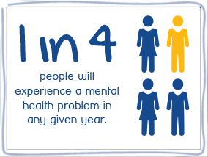
Our values

Mind's values are at the heart of everything we do.

- We put people first

- We’re stronger together

- We speak up for what’s right

- We never stop learning

- We demand better for mental health

About Cornwall Mind

Cornwall Mind was formed by the merger of two smaller Mind organisations in 2020. We are an independent CIO (Charitable Incorporated Organisation) responsible for its own income generation and governance. We are aligned with the vision and values of National Mind set out above as part of the Mind Federation.
We provide opportunities for recovery from mental ill-health and maintaining wellbeing for the People of Cornwall.

You can find out more by visiting our website at www.cornwallmind.org

Cornwall Mind is funded through diverse means including:

- Contracts with statutory bodies such as:
- NHS and Cornwall ICS (Integrated Care System)
- Charitable Trust grants
- Community events and fundraising
- Donations

About the Role

Wellbeing and Recovery Groups Facilitator
We’re proud to be part of the People in Mind programme, offering a wide range of wellbeing services across Cornwall.
Our wellbeing services support people to build resilience and reduce the onset of mental health problems. We offer a wide range of recovery focused groups and activities from outdoor projects to creative workshops, community-based groups and wellbeing programmes. We work with people to support them in achieving their goals and engaging in their local communities.
Alongside these services we offer a listening ear and a space to be heard; where we can provide the information, guidance and support needed to promote individual recovery and wellbeing.

What is People in Mind?
People in Mind (PiM) is a mental health and suicide prevention programme for Cornwall and the Isles of Scilly.
It is coordinated and managed by Cornwall Voluntary Sector Forum (VSF) and jointly funded by Cornwall & Isles of Scilly Integrated Care Board (ICB) and Cornwall Council Public Health.
The 5-year programme is aimed at supporting innovation and collaboration within the voluntary, community and social enterprise (VCSE) sector to deliver a trauma-informed and whole-family approach to improve the wellbeing of communities in Cornwall and the Isles of Scilly.
The PiM collaborative project offers targeted mental health support to people aged 16 and over and is delivered by a partnership of community organisations.
We are seeking a compassionate and skilled Mental Health Group Facilitator to lead mental health wellbeing groups for individuals experiencing a range of mental health challenges. In this role, you will be responsible for planning and facilitating group sessions that promote emotional well-being, build coping strategies, and encourage peer support in a safe and inclusive environment.
The ideal candidate will have experience working in mental health settings, strong interpersonal and communication skills, and the ability to foster trust and engagement among group participants. This position requires sensitivity, professionalism, and a commitment to promoting recovery-oriented care and mental health awareness.

Key Responsibilities

1. Facilitate Wellbeing and Recovery Groups
- Deliver and facilitate a range of group sessions, including the Five Ways to Wellbeing programme and Activity Recovery Groups, tailored to a variety of audiences and experience.
- Organise and facilitate groups at multiple venues across Cornwall.
- Support and collaborate with group volunteers to enhance group delivery.
- Promote each member’s strengths, creativity, and personal goals, helping them to achieve outcomes identified in their Recovery Action or Wellbeing Plans.
- Encourage group members to engage with progression and recovery opportunities both within Cornwall Mind and in the wider community.
- Monitor and review individual progress regularly, using tools such as the Warwick-Edinburgh Wellbeing Scale, and GAD-7.
- Maintain an emphasis on recovery, wellbeing, and self-management throughout all interactions.
- Accurately maintain records and activity logs using the Lamplight database.
- Stay informed about relevant local support services and community opportunities.

2. Build Positive Relationships
- Develop and maintain effective working relationships with key stakeholders, including community organisations and service providers.

3. Adhere to Cornwall Mind Policies and Procedures
- Maintain professional boundaries at all times.
- Promptly escalate any concerns regarding a member’s mental health to the appropriate line manager.
- Report any safeguarding concerns to Cornwall Mind’s safeguarding lead in a timely and appropriate manner.
- Comply with all risk assessments and health and safety guidelines related to activities.

4. Supervision and Training
- Attend regular supervision sessions, team meetings, and any required training.
- Proactively seek opportunities for personal and professional development.

Skills, Knowledge, Experience and Behaviours
Reference: | Essential | Desirable
E1 | Excellent communications skills, written and verbal
E2 |  | Relevant health/mental health/social care qualification
E3 |  | Understanding of Coaching or Motivational Interviewing techniques.
E4 | Experience of group facilitation
E5 | Understanding of how to support people during rehabilitation from mental illness.
E6 | Good knowledge of other providers (both statutory and VCO)
E7 |  | Safeguarding qualification
E8 | Knowledge of recovery and self-care tools
E9 |  | Experience of working within the 3rd sector
E10 |  | Understanding of Graded Exposure technique
E11 | Organised and good time management
E12 | Excellent professional boundaries
E13 | Flexible and adaptable
E14 | Reliability, honesty, integrity
E15 | Empowering
E16 |  | Experience of lone working
E17 | Access to own vehicle with UK license
E18 |  | Experience of mental health recovery, either for yourself or someone close to you.

Contract length: 12 Months
Application deadline:
Expected start date:
Job Type:
Salary: £12.60 per hour
Please use the below reference numbers when completing your application and personal statement. This will increase the likelihood of being selected for interview.

Qualifications, Skills and Knowledge
Reference: | Essential | Desirable
s1 |  | FE/HE qualification in relevant area
s2 | A strong working understanding of mental health issues
s3 |  | Knowledge of recovery models
s4 |  | Good knowledge of health and VCSE organisations
 | Able to handle multiple tasks, set priorities, work independently and in a team.
 | Good IT skills with the ability to use Microsoft Office 365, an online Case Record Management system such as Lamplight.
s5 | Must be able to travel around Cornwall as required (public transport encouraged where practical and/or have a driving license and access to vehicle) and the ability to communicate with colleagues using appropriate video technology.
s6 | Experience of providing wellbeing support and information to people.
s7 |  | Understanding of psychosocial support models
s8 | Professional understanding of group dynamics, boundaries and confidentiality.
s9 | Ability to communicate effectively in writing and orally.
s10 |  | Evidence of continuing professional development

Experience
Reference: | Essential | Desirable
e1 |  | Personal experience of recovery from mental ill-health
e2 |  | Experience of working within the 3rd sector
e3 | Experience of organising and prioritising a demanding workload
e4 |  | Experience of coaching or motivational interviewing
e5 | Demonstrable experience of facilitating groups
e6 | Experience of working with confidential and sensitive information.
e7 | Experience of lone working
e8 |  | Knowledge of safeguarding procedures
e9 | Experience of supporting people with mental ill health

Personal attributes
Reference: | Essential | Desirable
b1 | Approachable
b2 | Empathetic
b3 | Ability to work on own initiative with minimum supervision
b4 | Demonstrable commitment to Cornwall Mind’s equal opportunities and anti-discrimination ethos and the ability to incorporate it into practice.
b5 | Organised and good time management
b6 | Flexible and adaptable
b7 | Excellent listener
b8 | Belief that everyone can recover, however they chose to define that
b9 | Resilient
b10 | Positive attitude, enthusiasm and a sense of humour

Successful candidate will be required to obtain a DBS check

