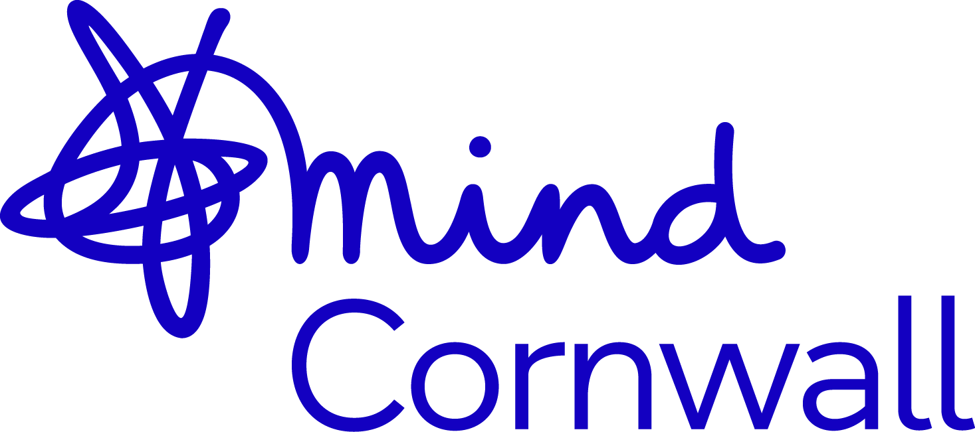

Application pack for the position of

Community Researcher -Coastal and Rural Mental Health Study
Date: June 2026

Cornwall Mind is committed to working towards a fairer world and does not discriminate against any employee or job applicant on the grounds of age, disability, gender reassignment, marriage and civil partnership, pregnancy and maternity, race, religion or belief, sex or sexual orientation.

The Mind Way – Values and Behaviours

- We put people first.
- We’re stronger together.
- We speak up for what’s right.
- We never stop learning.
- We demand better for mental health.

About Cornwall Mind

Cornwall Mind was formed by the merger of two smaller Mind organisations in 2020. We are an independent CIO (Charitable Incorporated Organisation) and aligned with the vision and values of National Mind set out above.

We provide opportunities for recovery from mental ill-health and maintaining wellbeing for the People of Cornwall.

Our vision
We won’t give up until everyone experiencing a mental health problem gets both support and respect.
Our mission
We endeavour to prevent those who are vulnerable from developing mental health issues. We provide advice and support to empower anyone experiencing a mental health problem. We campaign to improve services, raise awareness and promote understanding of mental health. We work throughout Cornwall.
Our goals
Staying well: Support people likely to develop mental health problems, to stay well.
Empowering choice: Empower people who experience a mental health problem to make informed choices about how they live and recover.
Improving services and support: Ensure people get the right services and support at the right time to help their recovery and enable them to live with their mental health problem.
Enabling social participation: Open the doors to people with experience of mental health problems participating fully in society.
Removing inequality of opportunity: Gain equality of treatment for people who experience both mental health and other forms of discrimination.
Organisational excellence: Make the most of our assets by building a culture of excellence.
About the Role

This role is about developing knowledge of mental health in coastal and/or rural community settings. Using an in-depth, on the ground, embedded approach, the post-holder will devote themselves to one place, spending time learning about how the community looks after its mental health, how they use mental health services (if they do), and whether changes in local services are better meeting their needs (or not) as coastal or rural residents.
The post-holder will work in Cornwall alongside a University of Plymouth researcher, and will also be part of a friendly national research team made up of researchers from the University of Northumbria, and the University of Lincoln, as well as the Community Researchers in Durham Dales and Lincolnshire. Training and support will be provided throughout the contract of employment, and there will be opportunity to develop research skills. Honorary Associate status will also be given for the University of Plymouth, providing access to training and development opportunities as well as other University resources.

Responsibilities

With support from a line manager at Cornwall Mind and the project researchers, the main responsibilities of this role are to collect and analyse data with a local community. Data collection will include: spending time in community settings to understand everyday experiences (non-participant observation), talking one-to-one with people about their views (interviews), working with groups to create shared understanding of the community (‘deep mapping’ workshops), and bringing people together to compare perspectives (focus group discussions).

We are taking a ‘realist’ approach to the research, which means we want to understand how and why change happens, and what influences people’s actions. Full training and ongoing support will be provided.

They will also co-facilitate the local patient and public involvement group and contribute to and attend a national Community of Practice, with other people involved in the study across the country, to share what they are learning and learn from other areas. Ethical approval for the study has been provided by the University of Plymouth.

What we are looking for

We need someone who has a deep commitment to social justice, equity and inclusive research, with lived experience of Cornwall (particularly North Cornwall Coast and Falmouth and Penryn) and strong interpersonal skills. Good knowledge and excellent experience in doing research with communities is also necessary, but you don’t need to have worked in a University or have a degree to apply. Attention to detail, and a thoughtful approach are also really important.
Person specification:

Essential
- Commitment to social justice, equity, and inclusive research.
- Strong interpersonal and listening skills – able to build trust, communicate sensitively, and record information accurately.
- Lived experience of Cornwall (particularly North Cornwall Coast and Falmouth and Penryn Primary Care Network areas) and an understanding of local communities.
- Knowledge of co-production and creative community engagement approaches
- Cultural awareness and sensitivity, particularly with underrepresented or marginalised groups.
- Research skills (e.g. interviews, focus groups, observation).
- Ability to analyse findings and contribute to reports or recommendations.
- Writing skills (e.g. report writing, funding applications, other kinds of formal writing)
- Basic IT skills
- Experience in mental health, social care, or community-based work or volunteering
- Experience working with diverse communities (ethnic, LGBTQ+, neurodivergent, faith).
- Knowledge of local assets and services in Cornwall (particularly North Cornwall Coast and Falmouth and Penryn).
- Training or awareness of trauma-informed or peer-support approaches.
- Must have a driving license, their own vehicle, and be prepared to travel across the county, and to the University when required. Few sites will be reachable via public transport.
- You will need to complete an enhanced DBS check as you will be working with vulnerable adults. We can help the successful candidate complete this process.
Desirable
- Lived experience of mental health challenges or close work with people experiencing them.
- Deep knowledge of Cornwall’s political, cultural, and historic context.
- Strong advocacy skills – representing community voices in wider forums.
- Ability to co-produce research or services with communities.
- Creative approaches to engagement (arts, digital media, storytelling).

Next steps
- Completion of our application form. (attached below) complete and return either as a word or pdf document. This will involve detailing (in no more than 2 sides of A4) why you are applying for this position. The personal statement should make reference to our essential and desirable requirements.
- Closing date 1st May 2026
- Interviews will be on 8th May 2026, with a view to starting employment as soon as possible, and by 9th June at the latest.
- For any further information please contact Lorna Richardson at Cornwall Mind lorna@cornwallmind.org or Rebecca Hardwick at University of Plymouth rebecca.hardwick@plymouth.ac.uk

Location: Bodmin with travel across Cornwall
Hours: 37.5 per week
Contract: 9th June – September 2027
Salary: £37,000 Per annum

Title of post applied for:

Advertisement seen in:

Surname or family name: |  |  | First or other names:
Address |  |  | Home Tel:
 |  |  | Mobile no:
 |  |  | Work Tel:
 |  |  | E Mail address:
 |  |  | Access to own car:
Name and address of current or most recent employer:

Job Title:

Dates:

Main duties:

If offered employment when could you start work?

Relevant training, qualifications or education, including dates:

Previous appointments (voluntary and paid) and dates, the most recent first:
Please give details of all posts held since leaving full-time education and account for any gaps in employment (if necessary, please continue on a separate sheet)
Dates |  | Employer (including address) |  |  | Job Title | Reason For Leaving
From: | To:

Personal Statement

The information in this section is crucial to assessing your application. Please state why you are interested in the job for which you are applying, and relate your experience, skills and personal qualities to the person specification and the job description. In addition to work and voluntary experience, you may wish to include other experience e.g. family duties, interests etc.
If you need more space, please continue on a separate page.
Do you consider yourself to have a disability either as by defined in the DDA Act 1995* or a physical or hidden disability that affects your day-to-day activities?

NO/YES If yes, please specify:

References
Please give the name and address of the persons to whom we could apply for a reference. One of the persons must be your present employer, or last employer if currently unemployed, or someone who knows you well if you have not been employed in the recent past. We require references to be obtained for the three year period immediately prior to commencement of employment. If the referees given below do not cover the last three years you may be asked to provide further references before an offer of employment is confirmed.
Name:  Address:  Tel. No:  Occupation:  In what capacity are you known to them? |  |  |  | Name:  Address:  Tel. No:  Occupation:  In what capacity are you known to them?
References will only be requested for shortlisted candidates and for any potential successful candidate
Criminal Offences

All convictions, including convictions which would otherwise be “spent” under the Rehabilitation of Offenders Act 1974, must be disclosed for the purposes of this job application. Cornwall Mind will determine the relevance of any convictions to the post applied for. If appointed to the position for which you are applying you will be required to apply for a Enhanced Disclosure.

Any information disclosed will be taken into consideration but will not automatically prevent your application from proceeding. However, if appointed, failure to disclose any criminal conviction now could lead to termination of your employment. Additional information will be made available to shortlisted candidates.

Have you ever been convicted of a criminal offence? Yes/No

If Yes, please give details on a separate page and enclose in a separate envelope
*Delete as necessary
All the information on this form is correct to the best of my belief.

Signed:

Note: This information will only be used for selection. Unsuccessful applications will be kept for 6 months after the interviews.
Please return this application form to either by email to lorna@cornwallmind.org or by post to

Cornwall Mind
2A Hamley Court,
Dennison Road,
Bodmin,
Cornwall, PL31 2LL

Cornwall Mind: Equal Opportunities Monitoring
We would be grateful if you could fill in this form, which should only take a few seconds. The information given is for recruitment monitoring purposes only and will not be seen by any recruitment panel.
Please put a tick in the boxes below which apply to you.
Q1. Are you | Male
 | Female
Q2. Are you | Under 18
 | 18 - 25
 | 26 – 45
 | 46 – 65
 | Over 65
Q3. Are you Registered Disabled | Yes
 | No

Q4. Ethnic Origin: | Are you:
 | White - | British
 |  | Irish
Any other White background
(please specify)
 | Mixed - | White and Black Caribbean
 |  | White and Black African
 |  | White and Asian
Any other Mixed background
(please specify)
 | Asian or Asian British - | Indian
 |  | Pakistani
 |  | Bangladeshi
Any other Asian background
(please specify)
 | Black or Black British - | Caribbean
 |  | African
Any other Black background
(please specify)
 | Chinese or other ethnic group - | Chinese
Any other
(please specify)



www.together-uk.org

